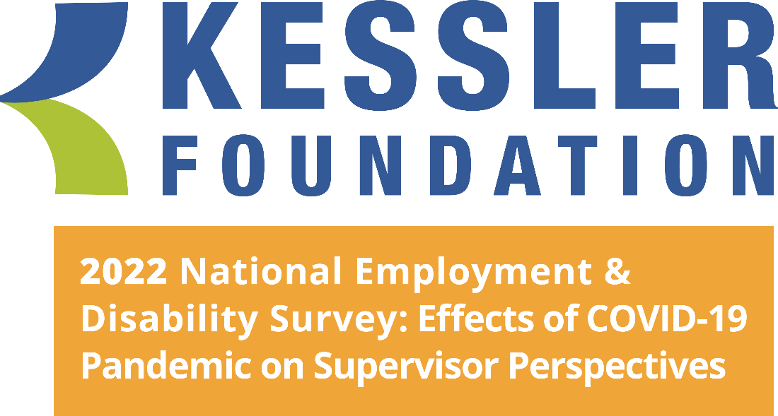

Report of Main Findings

Kessler Foundation . East Hanover, NJ . October 2022

Conducted by
the University of New Hampshire
Institute on Disability
Durham, NH

Prepared by
Andrew J. Houtenville, PhD, Professor of Economics and Research Director,
Institute on Disability, University of New Hampshire (UNH)

Debra L. Brucker, PhD
Research Associate Professor, Institute on Disability, UNH

Erica Jablonski, PhD
Postdoctoral Research Associate, Institute on Disability, UNH

John O’Neill, PhD, CRC
Director, Center for Employment and Disability Research, Kessler Foundation

Elaine E. Katz, MS, CCC-SLP
Senior VP of Grants and Communications, Kessler Foundation

Suggested Citation:
Kessler Foundation (2022). Report of Main Findings from Kessler Foundation 2022 National Employment and Disability Survey: Supervisor Perspectives.
East Hanover, NJ.

Table of Contents

Executive Summary i
Introduction 1
Objectives and Approach 2
Methods 3
Survey and Questionnaire Design 3
Data Collection 4
Participants 4
Employment Characteristics 5
Survey Findings 7
Recruiting Qualified Applicants 7
Hiring New Employees 9
Training New Hires 11
Providing Accommodations for Employees with Disabilities 13
Employee Retention 18
Conclusion 20
Closing Remarks 21
Appendix I: Demographic and Socioeconomic Characteristics of Survey Participants 23
Appendix II: Employment Characteristics of Survey Participants 25
Appendix III: References 26

2022 Kessler Foundation National Employment and Disability Survey:
Supervisor Perspectives

Executive Summary
Synopsis. Kessler Foundation, in partnership with the University of New Hampshire (UNH), conducted the 2022 Kessler Foundation National Employment and Disability Survey: Supervisor Perspectives (2022 KFNEDS:SP2) to examine the impact of the COVID-19 pandemic on employment practices as they relate to people with disabilities, to identify the practices used by employers to increase the employment of people with disabilities, and to understand supervisors’ views about the effectiveness of these practices. Building off the 2017 Kessler Foundation National Employment and Disability Survey: Supervisor Perspectives (2017 KFNEDS:SP) (Kessler Foundation and UNH, 2017), the 2022 KFNEDS:SP2 enables comparisons with supervisor perspectives today and pre-pandemic, capturing the impact of the national lockdown on employer practices and procedures to identify negative and/or positive changes since the original 2017 supervisor survey. The 2017 KFNEDS-SP was the first national survey to look at the effectiveness of the practices that employers used to recruit, hire, train, and retain people with disabilities in their organizations, from the unique perspective of supervisors of employees with and without disabilities. It was intended to provide direction for expanding inclusion of people with disabilities in the workplace.
The 2022 KFNEDS:SP2 builds upon the 2017 KFNEDS:SP survey, which used an innovative design to identify effective practices. Both surveys asked supervisors whether their organization used a particular employment practice, and if so, whether it was effective. When a practice applied to both people with and without disabilities, both surveys asked whether the practice was as effective with regard to people with disabilities. The 2022 KFNEDS:SP2 shows that employers have made some gains in recruiting, hiring, training, accommodating, and retaining people with disabilities in their organizations since the 2017 KFNEDS:SP. Moreover, it demonstrates some challenges that the COVID-19 pandemic presented as well as adaptive responses that many workplaces enlisted to combat those challenges.
Objective. The 2022 KFNEDS:SP2 was fielded in response to the COVID-19 pandemic, including questions designed to assess the impact of the pandemic on the employment of persons with disabilities, while also including questions similar to those included in the 2017 KFNEDS:SP survey to capture any changes that have occurred over the past five years in the processes and practices employers use to employ people with disabilities. Like the 2017 survey, the 2022 KFNEDS:SP2 addressed challenges common to employer-focused research by surveying supervisors on their own time, rather than while they were at work, allowing them to maintain their organizations’ anonymity, their personal anonymity, and avoid pressure to respond in “socially desirable” ways. The 2022 survey followed the design of the 2017 survey in measuring the effectiveness of employer practices for recruiting, hiring, training, accommodating, and retaining persons with disabilities. If a supervisor reported that their organization used a practice, they were then asked whether it was effective, and then, whether the practice was more effective, as effective, or less effective for people with disabilities. The design also delved inside organizational perspectives about employing people with disabilities—asking supervisors about the commitment of upper management relative to their own perspectives.
Methods. The 2022 KFNEDS:SP2 was conducted using standard, replicable survey practices. From May 11, 2022, to June 25, 2022, a sample of supervisors from U.S. employers was invited to take the survey as part of Qualtrics and partners business-to-business (B2B) panel. More than 14,000 respondents (n = 14,399) ages 18 and older consented to participate in accordance with UNH Institutional Review Board procedures. Of those, 1,587 were dropped because their organizations employed fewer than 25 people. Another 268 were removed for not supervising any direct reports in their current position, and 195 were dropped for indicating that they either did not understand the definition of disability as presented or did not wish to continue the survey. An additional 1,581 were dropped for inattentive or rushed responding. More than 6,000 (n=6,553) were excluded because the disability supervision quota was reached and 375 were excluded because the no disability supervision quota was reached.
Completed surveys were available from 3,840 respondents. Of those, 43 were removed by the researchers as they either did not report a state for their location of work or stated that they worked outside the U.S. The final analytic sample was 3,797 supervisors ages 18 and older working in the U.S. for organizations that employed 25 people or more.
COVID-19. An important set of findings from the 2022 KFNEDS-SP2 describes the impact of the pandemic on employment practices. Nearly half (47 percent) of supervisors shared that the COVID-19 pandemic had a moderate-to-large negative effect on their organizations. While 40 percent reported little or no change in the number of employees at their organizations, 38 percent reported moderate-to-large decreases in the number of employees. Forty-seven percent reported a moderate-to-large increase in the percentage of paid employees working from home. Of those who reported a moderate-to-large increase in working from home, 69 percent expected this percentage to increase in the coming years.
More than three-quarters (76 percent) of supervisors who worked in organizations with established accommodation processes stated that their organization used their established processes for employees who wanted to request accommodations because they were more susceptible to COVID-19. Seventy-eight percent of supervisors stated that their organization established or changed their accommodation processes due to issues created by COVID-19.
Forty percent of supervisors managed employees who experienced any lasting physical and/or mental effects of a COVID-19 infection. Of supervisors who managed these employees, 58 percent stated that the employees received accommodations. Eleven percent reported not providing accommodations because the effects of COVID-19 were not severe enough to decrease productivity, 19 percent reported not providing accommodations because the employee did not request them, and 11 percent stated that accommodations could not be provided because of the nature of the work. As the survey did not capture further details about the nature of work that precluded the provision of accommodations, further research in this area is needed.
Commitment of Upper Management. Another key finding of the 2022 KFNEDS:SP2 is that the importance supervisors gave to recruiting, hiring, training, accommodating, and retaining employees with disabilities at times mirrored that of upper management (in the case of hiring people with disabilities) and at other times was stronger than that of upper management (in the case of recruiting, training, accommodating, and retaining people with disabilities). Certain gains have been made since 2017 as well. In terms of hiring, for example, 32 percent of supervisors surveyed in 2022 felt it was very important to hire people with disabilities and 28 percent of upper management were viewed as very committed to this goal. These percentages have increased since 2017, yet commitment levels between supervisors and upper management were closely aligned in both years. In 2017, only 22 percent of supervisors felt it was very important to hire people with disabilities and 20 percent of upper management was viewed as very committed to hiring people with disabilities.
Supervisors’ commitments diverged from upper management’s perceived commitment in other areas. As one example, when asked about providing employees with requested accommodations, 57 percent of supervisors in the 2022 survey felt it was very important, while 40 percent of upper managers were seen as very committed. Slightly higher percentages were reported in the 2017 survey as 66 percent of supervisors felt it was very important to provide employees with requested accommodations and 47 percent of upper management were seen as very committed in this area.
Taken together, these results about the commitment of upper management suggest that while many supervisors in an organization may support the goal of employing people with disabilities, when it comes to the details of realizing that goal, supervisors are perceiving less commitment and support than needed from upper management.
Organizational Processes. Another important set of findings from the 2022 survey relate to organizational processes. Although some gains have been made, many organizational processes were still not viewed as effective for people with disabilities as they were for the general population. Supervisors in the 2022 survey reported that higher proportions of organizations had disability hiring goals (49 percent, compared to 28 percent in 2017). Seventy-five percent of supervisors in 2022 reported that their organizations had hiring goals for other types of diversity, an increase of 18 percentage points since 2017. However, in 2022, although most supervisors (90 percent) worked for organizations that had established processes for recruiting employees (an increase of six percentage points from the 2017 survey), of the organizations that had a standard recruiting process, most supervisors in 2022 (92 percent) and 2017 (90 percent) believed the process to be effective in general, but fewer (73 percent in 2022 and 61 percent in 2017) felt that this recruiting process was as effective or more effective for recruiting employees with disabilities. Similarly, in the 2022 KFNEDS:SP2, of the organizations that had a process to help new employees learn their jobs (91 percent), most supervisors (95 percent) believed the process was effective for employees in general, but fewer (68 percent) felt that process was as effective or more effective for employees with disabilities. In 2017, of the organizations that had a process to help new employees learn their jobs (86 percent), most supervisors (93 percent) believed the process was effective for employees in general, but fewer (73 percent) felt that process was as effective for employees with disabilities.
On a positive note, more supervisors in 2022 stated that their organizations (71 percent, compared to 66 percent in 2017) had a process to provide requested accommodations to employees with disabilities. Nearly all supervisors (95 percent) believed the process was effective, suggesting an opportunity to provide support for the 29 percent of organizations that would benefit by having a formal accommodation process in place. A higher percentage of supervisors reported that their organizations (39 percent) had a centralized accommodation fund compared to 2017 (16 percent). When organizations did have an accommodation fund, most supervisors (92 percent in 2022 and 94 percent in 2017) felt it was effective at improving their ability to provide requested accommodations to employees.
Specific Employer Practices. Findings from the 2022 KFNEDS:SP2 are similar in some ways to the 2017 survey in suggesting opportunities to engage employers about specific practices that supervisors find effective for improving their ability to employ or accommodate people with disabilities. Some practices are both widespread and effective. For example, in 2022, most organizations automatically used job shadowing (64 percent) and onsite training by supervisors and co-workers (71 percent) as ways to help new employees learn their jobs. In 2017, 66 percent of supervisors reported that they automatically used job shadowing and 73 used onsite training by supervisors and co-workers as ways to help new employees learn their jobs. Across both surveys, almost all supervisors (96 percent in 2022 and 97 percent in 2017) reported that job shadowing was effective for training employees, in general, although a lower percentage of supervisors in 2022 (86 percent) felt it was as or more effective for training employees with disabilities than in 2017 (81 percent).
More supervisors reported the use of flexible working arrangements in 2022 compared to 2017. For example, 26 percent of supervisors reported that their organizations offered job sharing as a flexible working arrangement for all employees in 2022, an increase of 13 percentage points since 2017. In 2022, most (84 percent) supervisors reported that their organizations offered employees the option of working from home some or most of the time. In 2022, a flexible work schedule was reported by 40 percent of supervisors as an accommodation practice that was automatically available to all employees. This was a large increase from 2017, when only 25 percent of supervisors reported similarly. Forty-four percent of supervisors in 2022 and 52 percent of supervisors in 2017 indicated that flexible work schedules could be offered at supervisor discretion or upon employee request.
Closing Comments. This Executive Summary highlights the major findings of the 2022 KFNEDS:SP2. Many more analyses are planned for these data, which will add to our understanding of the factors contributing to the employment of people with disabilities.

Introduction
Kessler Foundation, in partnership with the University of New Hampshire (UNH), conducted the 2022 Kessler Foundation National Employment and Disability Survey: Supervisor Perspectives (2022 KFNEDS:SP2) to examine the impact of the COVID-19 pandemic on employment practices as they relate to people with disabilities, to identify the practices used by employers to increase the employment of people with disabilities, and to understand supervisors’ views about the effectiveness of these practices.
Employers stand to enhance their workforce, increase profitability, and exhibit organizational responsibility by expanding the number of people with disabilities that they employ (Houtenville & Kalargyrou, 2012). The 2015 Kessler Foundation National Employment and Disability Survey (KFNEDS) showed that people with disabilities are striving to work and overcoming barriers to employment (Sundar et al., 2018). The 2017 Kessler Foundation National Employment and Disability Survey: Supervisor Perspectives (KFNEDS:SP) highlighted the practices that supervisors found most effective for recruiting, hiring, training, accommodating, and retaining people with disabilities while also identifying opportunities for improvement in these employment practices. However, the employment-to-population ratio of people with disabilities remained low (35%), compared to that of people without disabilities (75%) (Kessler Foundation and UNH, 2022), suggesting that further research was needed.
The 2022 KFNEDS:SP2 builds upon the 2017 KFNEDS:SP survey. Both used an innovative design to identify effective practices. Both surveys asked supervisors whether their organization used a particular employment practice, and if so, whether it was effective. When a practice applied to both people with and without disabilities, both surveys asked whether the practice was as effective with regard to people with disabilities. In 2022, the survey also asked whether the practice was more effective for people with disabilities. In order to gauge the potential uptake of a practice when not in use, respondents in both surveys whose organizations did not utilize a given practice were asked whether it would be feasible to implement. The surveys also delved inside organizational perspectives about employing people with disabilities, asking supervisors about the commitment of upper management relative to their own perspectives.

Objectives and Approach
The 2022 KFNEDS:SP2 aimed to:
- Provide new information about the impact of the COVID-19 pandemic on employment practices as they relate to persons with disabilities in the U.S.
- Understand the processes and practices employers use to recruit, hire, train, accommodate, and retain employees with disabilities
- Learn from supervisors’ perspectives about the effectiveness of employer practices related to the employment of people with disabilities
- Generate actionable information to support the adoption of promising practices across the country to positively influence employment outcomes for people with disabilities

Like the 2017 KFNEDS:SP, the sample for the 2022 KFNEDS:SP2 was generated from a pre-screened panel of business respondents maintained by Qualtrics and its partners. Respondents were not asked to disclose their employers. Beyond the anonymity of the employers, supervisors contacted through this approach were more likely to respond honestly because the surveys were completed on their own time and not as a part of their paid workday.
Another benefit to this approach was that using a pre-screened panel dramatically reduced costs and allowed for a much larger, more focused sample. By asking survey respondents about the strategies used at their organizations to support people with disabilities in their workplaces, the survey mode helped to overcome one of the largest barriers in disability research, which is to solicit information about employers. With its focus on processes and practices used and deemed effective, the 2022 KFNEDS:SP2 highlights feasible approaches to improve employers’ ability to successfully recruit, hire, train, accommodate, and retain qualified and talented employees with disabilities.

Methods

Survey and Questionnaire Design
The 2022 KFNEDS:SP2 was designed as an online survey of supervisors from U.S. organizations employing at least 25 workers, the minimum size of organizations responsible for complying with guidelines set forth by the Americans with Disabilities Act (ADA). The survey questionnaire was designed to ascertain supervisor perspectives about the impact of the COVID-19 pandemic on employment practices as well as the processes and practices used by their organizations to employ people with disabilities and the effectiveness of those practices. The questionnaire was developed by researchers at the UNH in consultation with Kessler Foundation and an advisory board. The survey protocol and procedures were approved by the UNH Institutional Review Board.
The main topic areas covered by the survey included the impact of the COVID-19 pandemic on employment practices and general recruitment, hiring, onboarding, training, accommodation, and retention of employees. Within each employment practice area, supervisors were asked whether their organization had a process (e.g., “Do you have a process to recruit qualified employees?”). When indicating that a process was in place, supervisors were next asked if the process was effective, in general. If they felt the process was effective (i.e., “somewhat effective” or “very effective”), they were asked whether it was “less effective,” “as effective,” or “more effective” for people with disabilities. In this way, information specific to employees with disabilities could be contextualized within the larger picture of the organizations’ overall effectiveness in relation to its employees.
Next, supervisors were asked to characterize their upper management’s commitment to hiring, training, and retaining employees with disabilities. To contrast with their perspective on upper management’s commitment, similar items also asked how important each of these areas was to the supervisors themselves. This not only provided a context through which to contrast the relative importance or commitment to each outcome, but also served as a mechanism to reduce pressure on supervisors to respond in socially desirable ways by allowing them to distinguish their own beliefs from those they attributed to upper management.
Finally, the survey asked about specific practices that were in place at supervisors’ organizations (e.g., “reviewing hiring practices to determine their accessibility for people with disabilities,” “allowing job sharing,” “flexible work schedules”). Supervisors indicated whether each practice automatically applied to all employees in general, was used in the past or upon employee request (or at supervisors’ discretion), or not typically used. As with the process questions, follow-up items regarding effectiveness (both in general and specific to people with disabilities) were asked whenever a practice was reported. When a practice was not used by an organization, or if supervisors were not certain whether a practice was used, they reported whether they thought the practice would be “feasible” in order to improve employment of people with disabilities. In this way, the survey helped to identify promising practices as those that were perceived to be most effective by employers who had used them and most feasible by employers who had not.

Data Collection
The 2022 KFNEDS:SP2 was conducted using standard, replicable survey practices.
Respondents of the survey included adults ages 18 and over who worked as supervisors in U.S. businesses and organizations. From May 11, 2022, through June 25, 2022, a sample of supervisors from employers around the country were invited to take the survey as part of Qualtrics and partners business-to-business (B2B) panel. Respondents were recruited by Qualtrics and its partner organizations using a variety of methods, including web intercept, targeted email lists, panel member referrals, and social media. Incentives for respondents included cash payments, free downloads, and/or membership points; all incentives were decided and allocated by Qualtrics and its partners. Informed consent to participate was obtained in accordance with requirements of the UNH Institutional Review Board. The median time to complete the survey was 13.0 minutes.

Participants
More than 14,000 respondents (n = 14,399) ages 18 and older consented to participate in accordance with UNH Institutional Review Board procedures. Of those, 1,587 were dropped because their organizations employed fewer than 25 people. Another 268 were removed for not supervising any direct reports in their current position, and 195 were dropped for indicating that they either did not understand the definition of disability as presented or did not wish to continue the survey. An additional 1,581 were dropped for inattentive or rushed responding. More than 6,000 (n=6,553) were excluded because the disability supervision quota was reached and 375 were excluded because the no disability supervision quota was reached. Completed surveys were available from 3,840 respondents. Of those, 43 were removed by the researchers as they either did not report which U.S. state they worked in or stated that they worked outside the U.S. The final analytic sample was 3,797 supervisors ages 18 and older working in the U.S. for organizations that employed 25 people or more.
Responses of the 3,797 supervisors were analyzed using Stata 17 (StataCorp, 2022). Of the 3,797 supervisors, approximately 55 percent were male, 44 percent were female, and less than one percent were transgender, nonbinary, or other genders. Fifty-two percent were between the ages of 35 and 50. Most (71 percent) had a college degree or higher, and 63 percent earned at least $75,000 annually. White non-Hispanic respondents comprised 74 percent of the sample; 9 percent were Black non-Hispanic, and 11 percent were Hispanic. Many of the supervisors surveyed had some personal experience with or exposure to disability: 16 percent experienced a hearing, vision, ambulatory, or cognitive disability themselves, and another 19 percent reported that someone close to them (e.g., family member, friend, colleague) had a disability. See Appendix I for detailed demographic and socioeconomic information on survey participants.

Employment Characteristics
Organizations of various sizes were represented in the 2022 survey results. Most supervisors (53 percent) were from organizations with 500 or more employees. Compared to recent data from the Census Bureau’s Statistics of U.S. Businesses (SUSB, 2013), the survey sample slightly overrepresented mid-sized organizations: 31 percent of respondents came from organizations with 100 to 499 employees, compared to 16 percent nationally. The remaining 16 percent represented smaller organizations with 25 to 99 employees.
In 2022, most (78 percent) respondents worked for private, for-profit organizations. Another 10 percent worked for non-profit organizations, and 13 percent were employed in the government sector. See Table 1. Supervisors who answered the survey came from a variety of industries. Besides the “other” category (21 percent), the most represented industries were professional, scientific, technical (14 percent); manufacturing (13 percent); health (11 percent); and the service industry (11 percent). More detail is provided in Appendix II.

Table 1. 2022 Survey Participants’ Employment Sector and Industry

Sector | Percent | Industry | Percent
Private for-profit | 78 | Professional, scientific, and technical | 14
Non-profit | 10 | Finance, insurance, and real estate | 9
Government | 13 | Administrative or support | 4
 |  | Service industry | 11
 |  | Education | 6
 |  | Health | 11
 |  | Manufacturing | 13
 |  | Construction | 8
 |  | Agriculture, forestry, or fishing | 1
 |  | Other | 21
 |  | Don’t know | 0.5

In 2022, more than half of the supervisors (70 percent) had been working at their current place of employment for 10 years or less, though 9 percent had been at their current employer for more than 20 years. The majority (57 percent) had been in a supervisory role for 5 years or less. Half (48 percent) supervised 10 or fewer direct reports, though 28 percent reported supervising more than 20 employees.
In 2022, nearly all of the supervisors (93 percent) had hired at least one person; 39 percent had hired 10 or fewer new employees, and 18 percent had hired more than 50. Ninety-two percent indicated that they had hired at least one person with a disability. This was a large increase over 2017, when 58 percent of supervisors indicated that they had hired at least one person with a disability. In 2022, the average number of people with disabilities hired was 6.
About half of the 2022 supervisors (48 percent) had some experience supervising people with disabilities, relatively unchanged since 2017 (51 percent). Of persons with such supervisory experience, 21 percent in 2022 and 20 percent in 2017 had supervisory experience with employees with hearing disabilities. Twenty-eight percent of 2022 supervisors and 9 percent of 2017 supervisors had experience with employees who had vision difficulties. Experience supervising individuals with mobility limitations was reported by 10 percent of supervisors in 2022 and 26 percent of supervisors in 2017. Finally, 19 percent of respondents in 2022 and 27 percent of respondents in 2017 reported having experience supervising individuals with cognitive limitations (i.e., “due to a physical, mental, or emotional problem, difficulty remembering, concentrating or making decisions”). See Appendix II for more detailed information on the employment characteristics of survey participants.

Survey Findings
The 2022 KFNEDS:SP2 asked supervisors about the impact of COVID-19 on their organization and about their employers’ general processes, practices, and levels of commitment to employees as related to several topic areas, including recruitment, hiring, onboarding, training, accommodating, and retaining employees. Once processes and specific practices were revealed, a set of follow-up questions was then used to discover whether strategies and approaches that were in place were considered effective, both for employees, generally, and for employees with disabilities, specifically.

COVID-19
One of the key findings of the 2022 KFNEDS:SP2 was that nearly half (47 percent) of supervisors reported that the COVID-19 pandemic had a moderate or large negative effect on their organizations. While 40 percent reported little or no change in the number of employees at their organizations, 38 percent reported moderate-to-large decreases in the number of employees. Forty-seven percent reported a moderate-to-large increase in the percent of paid employees working from home. Of those who reported a moderate-to-large increase in working from home, 69 percent expected this percentage to increase in the coming years.
More than three-quarters (76 percent) of supervisors who worked in organizations with established accommodation processes stated that their organization used their established process for employees who wanted to request accommodations because they were more susceptible to COVID-19. Seventy-eight percent reported that their organization established or changed their accommodation processes due to issues created by COVID-19.
Forty percent of supervisors reported supervising employees that experienced any lasting physical and/or mental effects of a COVID-19 infection. Of supervisors who supervised these employees, 58 percent stated that employees received accommodations. Eleven percent reported not providing accommodations because the effects were not severe enough to decrease productivity, 19 percent reported not providing accommodations because the employee did not request them, and 11 percent stated that accommodations could not be provided because of the nature of the work.

Recruiting Qualified Applicants
Figure 1 shows percentages of supervisors who reported that their organizations had a process to recruit new employees and supervisors’ estimation of the effectiveness of these processes in 2022. Most supervisors reported that their organizations (90 percent) had a process for recruiting new employees, and in 92 percent of cases, the supervisors felt these processes were effective at attracting qualified applicants. These percentages are higher than in 2017, when 84 percent had a process for recruiting new employees and 90 percent felt these processes were effective. In 2022, nearly three-quarters of supervisors (73 percent) felt the recruitment processes were as effective or more effective for recruiting applicants with disabilities.
More supervisors reported on recruitment efforts generally, and disability and diversity- specific recruitment efforts in 2022 compared to 2017. In 2022, 58 percent of supervisors reported that their organizations expended a “moderate” to “a lot of effort” on recruiting people with disabilities, while only 44 percent reported similarly in 2017. Seventy-nine percent of supervisors surveyed in 2022 worked for organizations that expended a “moderate” to “a lot of effort” recruiting for diversity, compared to 69 percent in 2017. Recruitment efforts in general increased from 74 percent in 2017 to 83 percent in 2022.
Recruiting practices. Supervisors were asked whether their organizations partnered with disability organizations to help them recruit qualified people with disabilities. In 2022, 43 percent answered affirmatively, an increase of 16 percentage points over the 27 percent who answered similarly in 2017. Of those who did use this practice, almost all (96 percent in 2022 and 95 percent in 2017) felt it was effective. A consistent concern was the percentage of supervisors who were not sure whether their organizations partnered with disability
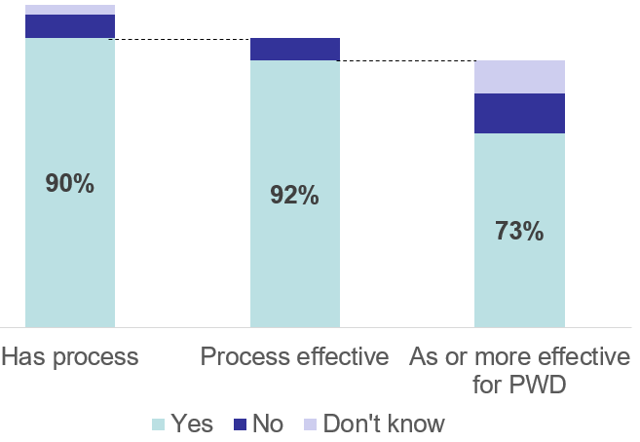

Figure 1. 2022 Organizations with recruiting processes and process effectiveness

organizations for recruitment (25 percent of supervisors in 2022, 35 percent of supervisors in 2017). Of those who were unsure, 87 percent in 2022 and 85 percent in 2017 believed it would be feasible to implement. Most supervisors whose companies did not partner with disability organizations to recruit (71 percent in 2022, 66 percent in 2017) agreed it would be feasible to do so to attract more qualified applicants with disabilities.

Hiring New Employees
In 2022, supervisors reported that, to some degree, upper management in their organizations was committed to hiring people with disabilities. As shown in Figure 2, 28 percent of upper-level managers were seen as “very committed” while another 48 percent were “somewhat committed.” In 2017, these percentages (not shown) were 20 percent and 45 percent, respectively.
Employing people with disabilities was an important priority for supervisors in 2022, mirroring the commitment they saw from management. Thirty-two percent of supervisors reported it was “very important” and 47 percent said it was “somewhat important.” In 2017, these percentages (not shown) were 22 percent and 46 percent, respectively.

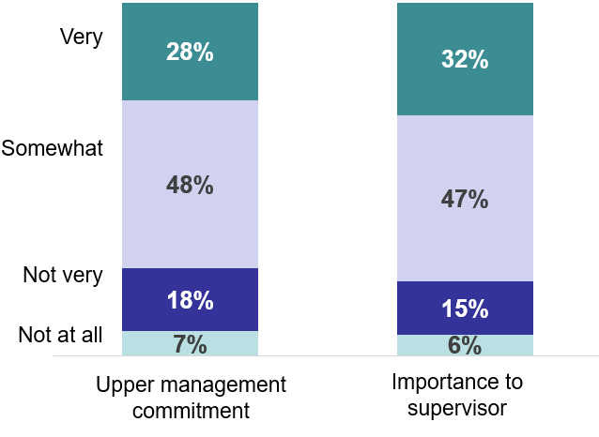
Figure 2. 2022 Commitment and importance of hiring people with disabilities

In 2022, 49 percent had company goals to hire people with disabilities, although a majority (75 percent) reported diversity hiring goals. Hiring practices. Supervisors were asked about specific employer practices related to hiring people with disabilities and they provided information about the perceived effectiveness and feasibility of those practices. A summary of the findings is provided in Table 2. Two hiring practices were seen by most as either effective (when used) or feasible (when not currently used).
In 2022, more than half (58 percent) of supervisors reported that their organizations provided training for supervisors in accessible application and interview techniques. This was a large increase over 2017 when only 40 percent reported similarly. Among those who used the practice in 2022, most (93 percent) felt it was effective for hiring people with disabilities. Among the 15 percent of supervisors who did not know whether their organizations offered training in accessible application and interview techniques, 82 percent felt it would be feasible to implement this practice. Seventy-one percent of supervisors whose organizations did not offer this training (27 percent did not) indicated that it would be a feasible strategy to make it easier for their organizations to hire qualified people with disabilities.

Table 2. 2022 Hiring Practices and Perceived Effectiveness (if used) or Feasibility (if not used)
 | Uses practice | Practice is effective | Would be feasible
Train supervisors in accessible application and interview techniques
Yes | 58% | 93% | --
No | 27% | -- | 71%
Don’t know | 15% | -- | 82%
Review or audit hiring procedures to ensure accessibility
Yes | 58% | 95% | --
No | 17% | -- | 64%
Don’t know | 25% | -- | 84%

Supervisors were also asked whether their organizations reviewed or audited hiring practices to ensure they were accessible to people with disabilities. In 2022, of the 58 percent whose organizations did this, 95 percent felt it was effective for hiring people with disabilities. In 2017, only 43 percent of organizations reviewed or audited their hiring practices to ensure accessibility.
In 2022, another 25 percent were not sure whether their organizations did this, although 84 percent of those supervisors felt it would be feasible to do so. Finally, of the 17 percent who said their organizations did not review the accessibility of their hiring practices, 64 percent felt it would be a feasible practice to implement.

Training New Hires
In 2022, most supervisors (91 percent) reported that their organizations had a process for supporting new hires to learn their jobs, and most (95 percent) who had a process felt it was effective. Over two-thirds (68 percent) also indicated that the process for supporting new employees to learn their jobs was as effective or more effective for people with disabilities as it was for employees in general. When supervisors reported that their organizations did not have a process by which employees were supported to learn their jobs, supervisors were asked whether their “current practices” were effective. In contrast to supervisors whose employers had a known process, fewer supervisors (58 percent) reported that their current practices for supporting employees to learn their jobs were effective and, of those, 68 percent felt the support provided was as effective or more effective for new hires with disabilities.

Training practices. Table 3 summarizes organizations’ utilization of three specific training practices in 2022, as well as supervisors’ perspectives about their effectiveness (when used) or feasibility (when not used). Supervisors were asked whether their organizations offered certain practices to help new employees learn their jobs, and they could select one of three responses. They could indicate that the practice was a) “automatically offered for all new hires,” b) “offered at supervisor discretion or upon new hire request,” or c) “not typically offered.”
In 2022, nearly three-quarters (71 percent) of organizations were reported to automatically offer all new employees onsite training by a supervisor or coworker as a way to help new hires learn their jobs. This is similar to the 73 percent reported in 2017. In 2022, of supervisors who worked at organizations that automatically offered onsite training, an overwhelming majority (96 percent) found this to be an effective practice. Eighty-seven percent of supervisors from these organizations reported onsite training by a supervisor or coworker to be as effective or more effective for helping employees with disabilities learn their jobs.
The same pattern held for organizations that offered onsite training by supervisors or coworkers only upon employee request or at the supervisor’s discretion in 2022. Onsite training was sometimes used by 26 percent of respondents’ organizations; of those, 90 percent found it effective, and 89 percent said it was as effective or more effective for employees with disabilities. These percentages are quite similar to those reported in 2017, when 25 percent of respondents’ organizations sometimes used this practice and, of those, 82 percent found it effective, and 86 percent said it was as effective or more effective for employees with disabilities.
Job shadowing was reported by similar proportions of supervisors in 2022 and 2017: 64 percent of supervisors in 2022 and 61 percent of supervisors in 2017 reported it as being automatically offered to all new hires to help them learn their jobs. Of these percentages, nearly all (97 percent in 2022 and 98 percent in 2017) found it effective. In 2022, 87 percent of these felt it was as effective or more effective for employees with disabilities, an increase from the 80 percent who felt it was as effective in 2017. Job shadowing was sometimes used at the organizations’ discretion by 29 percent of supervisors in 2022 and 27 percent of supervisors in 2017. Again, most respondents (94 percent in 2022 and 93 percent in 2017) found job shadowing to be effective. In 2022, 85 percent indicated that job shadowing was as effective or more effective for new hires with disabilities, an increase from the 75 percent in 2017 who indicated it was as effective or more effective for new hires with disabilities. In 2022, 8 percent of supervisors said that their organizations did not typically offer job shadowing, compared to 12 percent of supervisors in 2017. Of those who didn’t use it, 73 percent in 2022 and 70 percent in 2017 felt it would be a feasible way to help new employees learn their jobs.
Table 3. 2022 Training Practices and Perceived Effectiveness (if used) or Feasibility (if not used)
 | Uses practice | Practice is effective | Would be feasible
Onsite training by supervisor or coworker
Yes | 71% | 96% | --
Sometimes | 26% | 90% | --
No | 4% | -- | 61%
Job shadowing
Yes | 64% | 97% | --
Sometimes | 29% | 94% | --
No | 8% | -- | 73%
Short-term outside assistance
Yes | 32% | 93% | --
Sometimes | 34% | 88% | --
No | 33% | -- | 57%

In 2022, the third hiring practice supervisors reported about was offering short-term outside assistance such as job coaching. Offering short-term outside assistance was the least used of the three but was offered more often in 2022 than in 2017. In 2022, short-term outside assistance was automatically offered for all new hires at organizations represented by 32 percent of supervisors, a substantial increase from the 19 percent reported in 2017. In 2022, 93 percent of supervisors found it to be an effective way to help new employees learn their jobs, whereas in 2017, 89 percent of supervisors found this to be the case. In 2022, 92 percent of these indicated that it was as effective or more effective for new hires with disabilities. A slightly lower percentage (86 percent) found it as effective or more effective for employees with disabilities in 2017. In 2022, of the 34 percent who sometimes offered short-term outside assistance, 88 percent found it effective and of these, 91 percent said it was as effective or more effective for employees with disabilities. In 2017, of the 25 percent who sometimes offered short-term outside assistance, 82 percent found it effective. Of these, 86 percent said it was as effective or more effective for employees with disabilities.

Providing Accommodations for Employees with Disabilities
In 2022, more than two-thirds (71 percent) of supervisors reported that their organizations had a process for employees with disabilities to request accommodations such as specialized equipment, job reassignment, a modified work schedule, or extra assistance. This was a slight increase over the 66 percent of supervisors who reported similarly in 2017.
When a process was in place, nearly all supervisors (95 percent in 2022 and 96 percent in 2017) felt it was effective. A higher percentage of supervisors in 2022 (77 percent) than in 2017 (59 percent) reported that the accommodation process was discussed at a new employee orientation.
More supervisors reported that their organizations had a centralized accommodation fund, a general account tagged specifically to pay for applicant and employee accommodations in 2022 (39 percent) compared to 2017 (16 percent). When organizations had such a fund, it was almost always viewed (92 percent in 2022 and 94 percent in 2017) as effective at improving the ability to provide accommodations to employees with disabilities when requested.
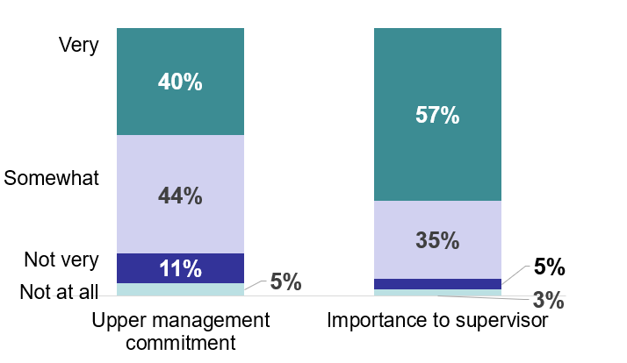
Figure 3. 2022 Commitment and importance of providing requested accommodations
Providing requested accommodations was important to supervisors, as Figure 3 shows. In 2022, most (57 percent) indicated that it was “very important,” and another 35 percent felt it was “somewhat important.” In 2017, 66 percent and 28 percent reported similarly. In comparison, supervisors in 2022 and 2017 perceived that upper management had a bit less commitment to providing employees with requested accommodations than they did. Supervisors indicated that 40 percent in 2022 and 47 percent in 2017 of upper-level managers were “very committed” to fulfilling accommodation requests. In 2022, 44 percent of upper-level managers were viewed as “somewhat committed” to fulfilling accommodation requests, compared to 39 percent in 2017. Only 8 percent of supervisors in 2022 and 6 percent in 2017 felt accommodations were “not very” or “not at all” important, compared to 16 percent of upper management (in 2022) and 14 percent of upper management (in 2017) who were seen as not committed to providing requested accommodations.
Accommodation practices. In 2022, supervisors were asked to report on three specific practices relating to flexible working arrangements (flexible work schedule, working from home, and job sharing), if these kinds of accommodations were widely available to employees with and without disabilities, and whether their organizations had a process in place to allow employees to disclose disabilities. Accommodation practices were described as automatically offered, offered at supervisor discretion or upon employee request, or not typically offered. When practices were not typically used, supervisors were asked whether those practices would be a feasible strategy to improve the organizations’ ability to employ people with disabilities. Table 4 shows organizations’ flexible working arrangements and their respective effectiveness for employees, generally, and employees with disabilities, specifically.
In 2022, a flexible work schedule was reported by 40 percent of supervisors as an accommodation practice that was automatically available to all employees. This was a large increase from 2017, when only 25 percent of supervisors reported similarly. Forty-four percent of supervisors in 2022 and 52 percent of supervisors in 2017 indicated that flexible work schedules could be offered at supervisor discretion or upon employee request.
Where automatically offered, 94 percent of supervisors in 2022 and 95 percent of supervisors in 2017 felt flexible work schedules were effective. Ninety-three percent of 2022 supervisors and 86 percent of 2017 supervisors indicated that this policy was as effective or more effective for employees with disabilities. Slightly fewer supervisors (90 percent in both 2022 and 2017) whose organizations sometimes offered flexible work schedules agreed that this was an effective tool to maintain the productivity of employees. In 2022, 87 percent of supervisors who worked in organizations that sometimes offered flexible work schedules said flexible work schedules were as effective or more effective a tool for employees with disabilities, compared to 79 percent in 2017. Among the 16 percent of supervisors whose organizations did not typically offer flexible work schedules in 2022, half (50 percent) felt it would be a feasible strategy to improve the organization’s ability to employ people with disabilities.

Table 4. 2022 Accommodation Practices re Flexible Working Arrangements and Perceived Effectiveness (if used) or Feasibility (if not used)
 | Uses practice | Practice is effective | As effective PWD | Feasible
Flexible work schedule
Yes | 40% | 94% | 93% | --
Sometimes | 44% | 90% | 87% | --
No | 16% | -- | -- | 50%
Working from home some of the time
Yes | 36% | 92% | 90% | --
Sometimes | 39% | 82% | 85% | --
Not | 25% | -- | -- | 28%
Working from home most of the time
Yes | 23% | 95% | 92% | --
Sometimes | 41% | 90% | 87% | --
No | 36% | -- | -- | 28%
Job sharing
Yes | 26% | 95% | 95% | --
Sometimes | 36% | 89% | 91% | --
No | 38% | -- | -- | 46%

In 2022, working from home was a second flexible working arrangement posed to supervisors as an accommodation practice. Figure 4 illustrates these results. Forty-two percent said their organizations automatically allowed employees to work and 35 percent of supervisors said their organizations allowed employees to work from home at supervisor discretion. Overall, supervisors viewed working from home as very effective for employees in general as well as for employees with disabilities. As detailed in Table 4, working from home was examined further based on whether it was offered most of the time or some of the time.
Working from home most of the time was an option frequently offered by organizations: 23 percent of supervisors said their organizations automatically allowed employees to work from home most of the time, and another 41 percent said they allowed frequent working from home upon employee request or at the supervisor’s discretion. In total, 92 percent of supervisors whose organizations offered working from home most of the time as an accommodation felt this practice was effective, including 95 percent of supervisors whose organizations offered the practice automatically for all employees and 90 percent who offered it at supervisor discretion. A large proportion of respondents (36 percent) reported that working from home most of the time was not typically allowed. Of these, 28 percent felt allowing employees to work from home at least some of the time would be a feasible strategy to improve their ability to employ people with disabilities.
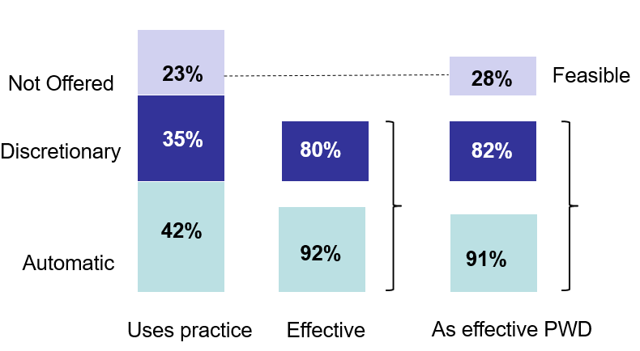
Figure 4. 2022 Organizations that offer working from home and supervisors’ perceptions of effectiveness (if used) or feasibility (if not used)
In 2022, 87 percent of supervisors whose organizations offered working from home some of the time as an accommodation felt this practice was effective, including 92 percent of supervisors whose organizations offered the practice automatically for all employees and 82 percent who offered it based on supervisor discretion or employee request. A quarter of respondents (25 percent) reported that working from home some of the time was not typically allowed. Of these, just over one-fourth (28 percent) felt allowing employees to work from home at least some of the time would be a feasible strategy to improve their ability to employ people with disabilities.
Job sharing was the third flexible working arrangement accommodation practice examined. In 2022, 26 percent of supervisors reported that their organizations automatically offered job sharing, an increase from the 13 percent of supervisors who reported similarly in 2017. In both years, 95 percent of those supervisors felt it was effective. In 2022, 95 percent considered job sharing as effective or more effective for employees with disabilities. In 2017, 92 percent felt similarly.
Thirty-six percent of supervisors in 2022 and 37 percent in 2017 said that job sharing was offered at the supervisor’s discretion or upon employee request. Of those, 89 percent in 2022 and 86 percent in 2017 felt it was an effective tool to maintain employee productivity. In 2022, 91 percent indicated that it was as effective or more effective for employees with disabilities, compared to 84 percent for 2017. Among the 38 percent of organizations reported not to offer job sharing in 2022, just under half (46 percent) of supervisors felt it would be a feasible strategy to improve their organizations’ ability to employ people with disabilities. In 2017, among the 57 percent of organizations that reported not to offer job sharing, just under half (48 percent) of supervisors felt it would be a feasible strategy to improve their organizations’ ability to employ people with disabilities.

Table 5. 2022 Practices to Retain Employees with Disabilities and Perceived Effectiveness (if used) or Feasibility (if not used)
 | Uses practice | Practice is effective | Would be feasible
Train employees regarding disability issues and cultural competence
Regularly | 58% | 95% | --
In the past | 23% | 85% | --
No | 19% | -- | 68%
Consult guidance from federal, state, or local resources
Regularly | 47% | 93% | --
In the past | 33% | 86% | --
No | 20% | -- | 64%

In 2022, 66 percent of supervisors reported that their organizations had a process that allowed employees to anonymously disclose disabilities or health conditions. In 2017, only 18 percent of supervisors reported similarly. In 2022, 19 percent indicated they were not certain whether there was a disclosure process in place, and the remaining 16 percent said there was no process to anonymously disclose disabilities or health conditions. In 2017, 30 percent indicated they were not certain whether there was a disclosure process in place, and the remaining majority (51 percent) said there was no process to anonymously disclose disabilities or health conditions.

Employee Retention

Retention practices. Commonly cited barriers to employment that people with disabilities face include negative attitudes, stigma, stereotypes, and assumptions on the part of supervisors and employers (Schur, Kruse, Blasi, & Blanck, 2009; Sundar et al., 2019). Successful retention of employees with disabilities can be improved by addressing these barriers. As such, supervisors were asked whether their organizations offered training to employees about disability issues and cultural competence to improve knowledge and attitudes about colleagues with disabilities. Results are summarized in Table 5 and illustrated in Figure 5. In 2022, more than half (58 percent) reported that their organizations did this regularly, and 95 percent of those supervisors believed it was effective at improving the organization’s ability to employ or accommodate people with disabilities. In 2017, almost half (43 percent) reported that their organizations did this regularly, and 94 percent of those supervisors believed it was effective at improving the organizations’ ability to employ or accommodate people with disabilities.
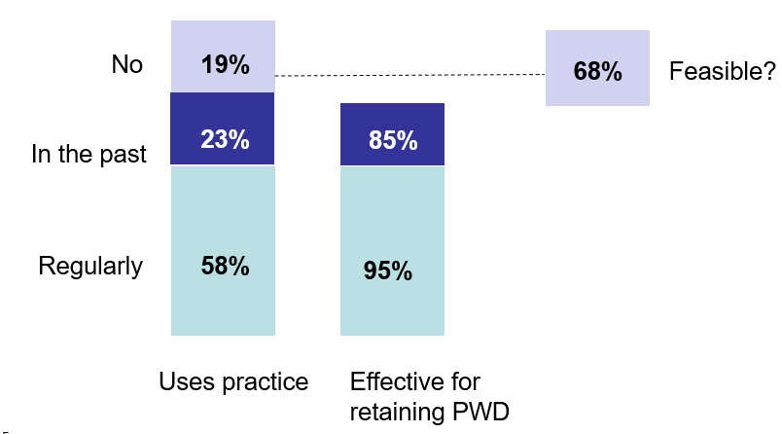
Figure 5. 2022 Organizations that offer cultural competence training and supervisors’ perceptions of effectiveness (if used) or feasibility (if not used)

In 2022, 23 percent of supervisors indicated that their organizations had offered cultural competence with disability training in the past, similar to the 27 percent reported in 2017. Of supervisors who worked in organizations that offered cultural competence with disability training in the past, 85 percent said it was effective in each year. In 2022, only about one-fifth (19 percent) of supervisors’ organizations did not offer cultural competence training regarding disability issues, but 68 percent of those supervisors said it would be a feasible practice to implement. In 2017, a higher proportion (30 percent) did not offer such training, but 80 percent of those supervisors said it would be feasible to implement.
Because retention and accommodation practices often are linked when it comes to employees with disabilities, supervisors were also asked whether they consulted guidance from federal, state, or local resources regarding the provision of accommodations. This practice was regularly undertaken by 47 percent of supervisors’ organizations in 2022 and had been done in the past by another 33 percent. In 2017, this practice was regularly undertaken by 40 percent of supervisors’ organizations and had been done in the past by another 34 percent.
Among organizations that did this regularly in 2022, most (93 percent) supervisors believed that consulting guidance from federal, state, or local resources was an effective way to improve their organizations’ ability to employ or accommodate people with disabilities. Eighty-six percent of supervisors whose organizations had used this practice in the past reported that it was effective. Among the 20 percent of supervisors from organizations that did not use this practice, 64 percent felt it would be a feasible strategy to improve their ability to employ or accommodate people with disabilities.

Conclusion
The 2022 KFNEDS:SP2 was conducted to further our understanding of the impact of the COVID-19 pandemic on employment practices and to understand, more generally, the processes and practices used by employers to increase the employment of people with disabilities and to discover, from the supervisor’s perspective, the effectiveness of these practices.
Almost half (47 percent) of the supervisors reported a moderate-to-large increase in the percentage of paid employees working from home in 2022. Of those who reported a moderate-to-large increase in working from home, 69 percent expected this percentage to increase in the coming years. Of note, 40 percent of supervisors reported supervising employees who experienced any lasting physical and/or mental effects of a COVID-19 infection, but only 58 percent of these supervisors stated that these employees received accommodations. Eleven percent stated that accommodations could not be provided because of the nature of the work.
Overall, employers are making strides in recruiting, hiring, training, accommodating, and retaining people with disabilities. For example, the importance that supervisors gave to hiring people with disabilities mirrored their perceived commitment of upper management to hire people with disabilities. However, compared to the perceived commitment of upper management, supervisors attached much more importance to recruiting, training, accommodating, and retaining employees with disabilities.
Most employers have processes in place for recruitment and training, which are typically seen as effective for employees, generally, and employees with disabilities, specifically. Many (71 percent) employers also have a process to provide requested accommodations and nearly all supervisors believed these processes were effective. This suggests an opportunity to support the 29 percent of supervisors’ organizations that do not have such a process.
Findings from the 2022 KFNEDS:SP2 also suggest opportunities to further investigate and engage employers regarding specific practices they undertake. Some practices are only automatically used or offered by relatively few employers. However, these practices are often seen as effective by those who use them and feasible by those who do not. Examples include partnering with disability organizations to recruit qualified applicants with disabilities, utilizing short-term outside assistance (e.g., a job coach) to help employees with disabilities learn their jobs, and offering job sharing to make it easier to employ or accommodate people with disabilities. Many more analyses are planned for the data collected from the 2022 KFNEDS:SP2, which will add to our understanding of the factors contributing to the employment of people with disabilities. For example, what are the characteristics of employers (e.g., industry, company size) most successfully striving to employ people with disabilities? Answers to this and related research questions will inform future educational efforts and the provision of support to employers and, along with findings in this report, will suggest which interventions may be most effective in which types of organizations.
The 2022 KFNEDS:SP2 also generated answers to many open-ended questions that delve deeper into supervisors’ perspectives and experiences working with people with disabilities. Qualitative data from these questions are likely to reveal emerging practices not yet fully recognized in the field of employment and disability. Updates on this report, as well as future results and publications, can be found at KesslerFoundation.org/kfsurvey22.

Closing Remarks
The 2022 KFNEDS:SP2 offers important new information for employers, policymakers, legislators, and the disability community about the impact of the COVID-19 pandemic on employment practices as they relate to persons with disabilities and about the progress being made to better support the employment of persons with disabilities. The COVID-19 pandemic has particularly highlighted the importance of accommodating employees with disabilities. More research is needed to understand why employees with lingering COVID-19 symptoms who worked in certain occupations were less likely to receive accommodations. The survey results also highlight how supervisors continue to perceive their upper management as generally less committed to recruiting, training, accommodating, and retaining persons with disabilities than they are. Further research into this disparity is needed, not only to validate it from the view of upper management but also to determine the most effective ways that upper management can communicate such commitment organization-wide. Information about the utilization and effectiveness of workplace practices will engender new priorities, policies, and programs to educate and assist employers as they strive to expand practices with the greatest potential for improving employment outcomes of people with disabilities.

Appendix I: Demographic and Socioeconomic Characteristics of Survey Participants

Table A1-1. 2022 Sample Demographics and Socioeconomic Information with National Benchmarks from the U.S. Census

 | Survey Sample |  | U.S. Census
 | Number | Percent | Percent
Total | 3,797 | 100.0 | 100.0
Gender
Male | 2,101 | 55.4 | 50.0
Female | 1,679 | 44.2 | 50.0
Other | 17 | 0.4
Age
18 to 34 | 992 | 26.1 | 31.9
35 to 50 | 1,991 | 52.4 | 35.6
Over 50 | 814 | 21.4 | 32.5
Race (non-Hispanic)/Ethnicity
White only | 2,791 | 73.6 | 63.7
Black only | 328 | 8.7 | 12.2
Other single race | 188 | 5.0 | 0.2
Two or more races | 56 | 1.5 | 1.9
Hispanic | 424 | 11.3 | 16.3
Education
Less than high school | 1 | 0.5 | 11.9
High school or equivalent | 18 | 9.1 | 26.8
Some college/technical school | 1,100 | 19.9 | 32.7
College degree | 1,743 | 45.9 | 18.7
Postgraduate | 934 | 24.6 | 9.9
Annual Household Income
Less than $15,000 | 28 | 0.8 | 16.9
$15,000 to 29,999 | 138 | 3.7 | 17.4
$30,000 to 44,999 | 296 | 7.9 | 14.2
$45,000 to 59,999 | 440 | 11.8 | 11.0
$60,000 to 74,999 | 482 | 12.9 | 8.6
$75,000 to 99,999 | 895 | 23.4 | 9.8
$100,000 and over | 1,484 | 39.7 | 22.1
(Continued)

 | Survey Sample |  | U.S. Census
 | Number | Percent | Number
Disability Status
Hearing difficulty¹ | 118 | 3.1 | 28.1
Vision difficulty¹ | 100 | 2.6 | 18.3
Ambulatory disability¹ | 184 | 4.9 | 52.4
Cognitive disability¹ | 343 | 9.0 | 49.1
Any of the 4 types | 603 | 15.9 | 12.6
Other type of disability | 46 | 1.2 | --
Emotional, psychological, or mental  health conditions | 990 | 26.1 | --
Intellectual or developmental disability | 228 | 6.0 | --
No disabilities | 3,157 | 83.1 | 87.4
¹Sum is greater than sample size because people may have multiple disabilities.

Appendix II: Employment Characteristics of Survey Participants

Table A2-1. 2022 Sample Employment Characteristics with National Benchmarks from the U.S. Census
 | Sample Survey |  | U.S. Census
 | Number | Percent | Percent
Total | 3,797 | 100 | 100
Organization Size
25 to 99 | 617 | 16.3 | 30.6
100 to 499 | 1,158 | 30.5 | 16.0
500 or more | 2,022 | 53.3 | 53.4
Industry
Professional, scientific, technical | 541 | 14.3 | 11.3
Finance, insurance, real estate | 350 | 9.2 | 2.1
Administrative or support | 159 | 4.2 | 4.6
Service industry | 417 | 11 | 9.8
Education | 230 | 6.1 | 9.2
Health | 425 | 11.2 | 13.8
Manufacturing | 510 | 13.4 | 10.3
Construction | 306 | 8.1 | 6.4
Agriculture, forestry, fishing | 38 | 1.0 | 1.9
Other | 802 | 21.1 | 16.4
Not answered | 19 | 0.5 | --

Appendix III: References

Bruyère, S. M., Erickson, W. A., & Horne, R. (2002). Survey of the federal government on supervisor practices in employment of people with disabilities. Ithaca, NY: Cornell University.

Dixon, K. A., Kruse, D., & Van Horn, C. E. (2003). Americans’ attitudes about work, employment and government. Work trends. Restricted access: A survey of employers about people with disabilities and lowering barriers to work. New Brunswick, NJ: Rutgers University.

Domzal, C., Houtenville, A., & Sharma, R. (2008). Survey of employer perspectives on the employment of people with disabilities: technical report. Prepared under contract to the Office of Disability and Employment Policy, US Department of Labor). McLean, VA: CESSI.

Erickson, W. A., von Schrader, S., Bruyère, S. M., & VanLooy, S. A. (2014). The employment environment: Employer perspectives, policies, and practices regarding the employment of persons with disabilities. Rehabilitation Counseling Bulletin, 57(4), 195-208.

Houtenville, A., & Kalargyrou, V. (2012). People with disabilities: employers’ perspectives on recruitment practices, strategies, and challenges in leisure and hospitality. Cornell Hospitality Quarterly, 53(1), 40-52.

Kessler Foundation & University of New Hampshire (2017). Kessler Foundation (2017). Report of Main Findings from the Kessler Foundation 2017 National Employment and Disability Survey: Supervisor Perspectives. East Hanover, NJ.

Kessler Foundation & University of New Hampshire. (2022). nTIDE August 2022 Jobs Report.

Schur, L., Kruse, D., Blasi, J., & Blanck, P. (2009). Is disability disabling in all workplaces? Workplace disparities and corporate culture. Industrial Relations, 48(3), 381-410.

StataCorp. (2012.) Stata Statistical Software: Release 15. College Station, TX: StataCorp LLC.

Sundar, V., O’Neill, J., Houtenville, A. J., Phillips, K. G., Keirns, T., Smith, A., & Katz, E. E. (2018). Striving to work and overcoming barriers: Employment strategies and successes of people with disabilities. Journal of Vocational Rehabilitation, 48: 93-109. doi: 10.3233/JVR-170918.

Taylor, H., Krane, D., & Orkis, K. (2010). The ADA, 20 years later. New York: Harris Interactive (conducted for the Kessler Foundation and National Organization on Disability).

U.S. Department of Justice. (2009). A guide to disability rights laws. Retrieved from https://www.ada.gov/cguide.htm

von Schrader, S., Malzer, V., & Bruyère, S. (2014). Perspectives on disability disclosure: The importance of employer practices and workplace climate. Employee Responsibilities and Rights Journal, 26, 237-255. doi 10.1007/s10672-013-9227-9

